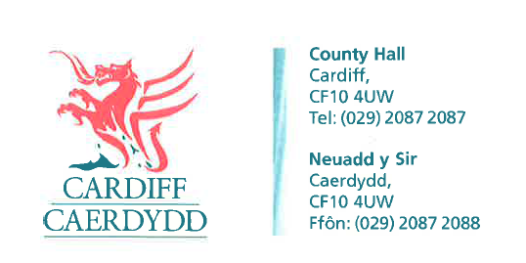
FOI Response Document
FOI17147

Thank you for your request under the Freedom of Information Act 2000 about Waste received on 20/12/2021.

Request
I am requesting the following information regarding recycling and waste processing under the Freedom of Information Act:
- Information relating to the collection of waste
  - Names of the companies involved
Response: Cardiff Council can confirm that all waste collections are done in house.
  - Types of materials collected by each
Response: N/A. All waste collections are done in-house

  - Tonnes collected by each per month or year
Response: This information is available by other means; we therefore will not be providing the information in the format requested under Section 21 of the Freedom of Information Act 2000.
The information you have requested can be found on the Waste Data Flow internet site. This can be accessed via the below link:
www.wastedataflow.org
Please note that a new account will need to be made to access the information on the Reporting section of the site. In accordance with Section 17 of the Freedom of Information Act 2000 and for the reasons stated above, this letter acts as a Refusal Notice.

  - Charge per tonne or equivalent charged to Council
Response: N/A. All waste collections are done in-house.
- Information related to the sorting of recyclable material
  - Names and addresses of the companies that the waste is sent to be sorted (MRF/ PRF/ Paper mill)
Response: Cardiff Council can confirm that most of its recycling is processed In-House. Recycling that is not processed in house, will be handled at Bywater’s (Leyton) Ltd. Cardiff Council can confirm that DMR (Dry Mixed Recycling) is sent to Prichard’s for processing.
  - Material sorted in each facility
Response: We can confirm the requested information is held by Cardiff Council however, the information is commercially sensitive and therefore exempt from disclosure.
In accordance with section 17 of the Freedom of Information Act 2000 this acts as a Refusal Notice.

The exemption applied is Section 43(2) Prejudice to Commercial Interests.
This exemption applies because disclosure of this information would be likely to prejudice the commercial interests of Cardiff Council and the Third Party the information relates to. This is because the requested information relates to the contract agreement between Cardiff Council and its third parties, releasing the information could harm this contract.

Under the Freedom of Information Act 2000 we must also consider if it is in the public interest to disclose the information relating to your request. In this case we consider that the public interest in withholding the information outweighs the public interest in disclosing it for the reasons explained below.

Factors Favouring Non-disclosure:
- Disclosure of the information could prejudice the commercial relationship between the Council and its suppliers by reducing existing trust and commercial confidentiality.
- Disclosure of the information could prejudice the Council achieving best value for public money by risking possible loss of the bespoke contract and rates.
- Disclosure of the information could result in disadvantage for the supplier in a tendering exercise, and potentially discourage the current and potential future suppliers in participating in any exercise for both Cardiff Council and other public authorities.

Factors Favouring Disclosure:
- Transparency, openness and accountability in Public Authority decision making.
- Accountability through the right to public debate for the spending of Public money.

  - Tonnage processed by each broken out by material type
Response: Please see the response to Q1c
  - Gate fee per material type charged by each facility

- Response: Please see the response to Q2b
Information relating to the resale of sorted material
  - Names of companies that recycled waste is sold to
  - Type of material sold to each
  - Tonnes sold to each
  - Sale price per tonne or equivalent
Response: This information is available by other means; we therefore will not be providing the information in the format requested under Section 21 of the Freedom of Information Act 2000. The information you have requested can be found on the Waste Data Flow internet site. This can be accessed via the below link:
www.wastedataflow.org
Please note that a new account will need to be made to access the information on the Reporting section of the site. In accordance with Section 17 of the Freedom of Information Act 2000 and for the reasons stated above, this letter acts as a Refusal Notice.
The WDF does not hold details of price per tonne, or any other finance details. however, the information is commercially sensitive and therefore exempt from disclosure, please see the response to Q1b for the full explanation for this exemption.

- Information relating to the final destination of recycled waste
  - Names of every company where the material ends up and is reconverted e.g. Pelletised / extruded to sheet
  - % of waste that is exported to Europe / Asia/ elsewhere
Response: Please see the response to Q3

If you have any queries or concerns, please do not hesitate to contact us.
Please remember to quote the reference number above in any future communications.

